
FACULTY OF INFORMATION COMMUNICATION TECHNOLOGY
DEPARTMENT OF INFORMATION COMMUNICATION TECHNOLOGY
YEAR: 2026

By:
Ondela Skwatsha (ST10454909)
Olilitha Adam (ST10446080)
Tuleka Nikelo (ST10448479)
Avuyile Dumezweni (ST10446143)

Open Source Coding - POE

Lecturer
Ms N Kolanda
Ms Nokukhanya Mnyango

15 June 2026

Introduction 3
Overview of the App 3
Innovative features: 4
Requirements list 4
Screenshots 7
Entity Relationship Diagram (ERD): 16
Project plan: 17
Conclusion 18
Improvements on section 2 19
Introduction 19
Overview of the App 19
Innovative features: 20
Requirements list 20
User Interaction Design 23
Screenshots 23
UML Use-case diagram 34
Project plan 35
References 36

Introduction
This report evaluates the creation of our personal budget application called BloomBudget. It has a simple interface that helps users navigate their financial behaviours smoothly. BloomBudget is designed to promote better money management by enabling users to track their income, expenses, and savings in a structured and visually engaging way, as well as setting goal-oriented budgets with some collaboration from friends and family. By using research insights from Vault22, Wallets, and Spendee, we are informed of the general features that budgeting apps have and how they are implemented, as well as creating an application that is unique to the others.

Overview of the App
Name of the app: BloomBudget
Slogan: Track your money. Grow your future.

Initial Icon Design:


Innovative features:
- Home screen widget: BloomBudget will offer a feature where users can add or log expenses into their budget via the home screen. This aims to provide a shortcut for the users rather than going into the application.
- Notification reminders: Users are issued reminders
- Questionnaire: Provide a few questions asking the user about how well-versed they are in budgeting to offer additional assistance if they are not well educated.
- Shared wallets: Group budgeting feature for families, friends, or teams to manage collective expenditure.
- Bank connectivity: The ability to connect to local banks

Requirements list
User registration and login
- The user must be able to register and login to the app using a username and password. When they register, they must fill in their first name, last name, their username, and then create a password. The user is only required to enter their username and password when logging in.

Expense Categories
The user must be able to create, edit, and delete categories for expenses. These categories must consist of Entertainment, Food & Drinks, Shopping, Bills & Fees, Health, Transport, Travel, Groceries, Car, and Personal. This requirement is to ensure that the user can study their spending habits, and which expense uses a lot of money.

Expense Entry
- The user must be able to add an expense entry, specifying at least the amount, date, description, and category. This requirement is to provide specific details about the expense entry which will assist the user for future planning.
- The user must be able to optionally attach a photo. When the user adds the expense entry, the photo must be visible on the dashboard. This aims to help the user remember visually what the entry was logged for.
Report
- The user must be able to view a list of all expenses during a user-selectable period. This requirement is to enable the user to see the transactions that took place during the selected time period. The user can view the transaction weekly, bi-weekly, monthly, or annually.
Budget goal setting
- The user must be able to set a monthly total budget goal and specific limits for individual categories. This requirement is to ensure that the user does not go overboard on certain expenses unnecessarily. For example, the user will set a limit of R450 on the Entertainment category to ensure that they do not exceed this limit for that month.
Database
- All this data must be saved to the local database. Data integrity will be maintained through encryption protocols. This is a requirement so that data can be easily managed and retrieved efficiently.
Graph and visualization
- The user must be able to view a graph showing daily spending over a user-selectable period. This assists the user by tracking their spending habits visually. With the use of graphs, it is easier to identify certain trends in the spending and overall understanding the presented data.
Homescreen widget
- The user must be able to add the app’s widget into their home screen. This should allow them to add or remove expenses on their homescreen.
Notifications
- The user must be able to receive notifications about their progress or reminders to log and review budgets.
Shared wallets
- The user must be able to share their wallet or budget with their friends or family. They must be able to make changes to entries or add their own entries on the same account.
Bank integration
- The user must be able to connect their bank to the application.

Screenshots
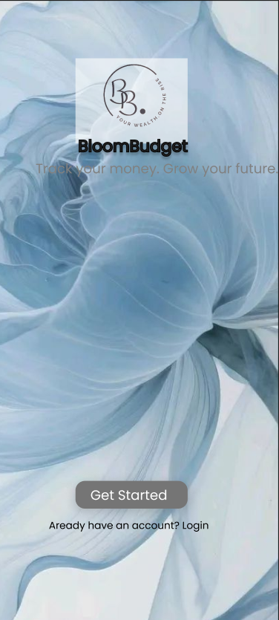
- BloomBudget main screen.
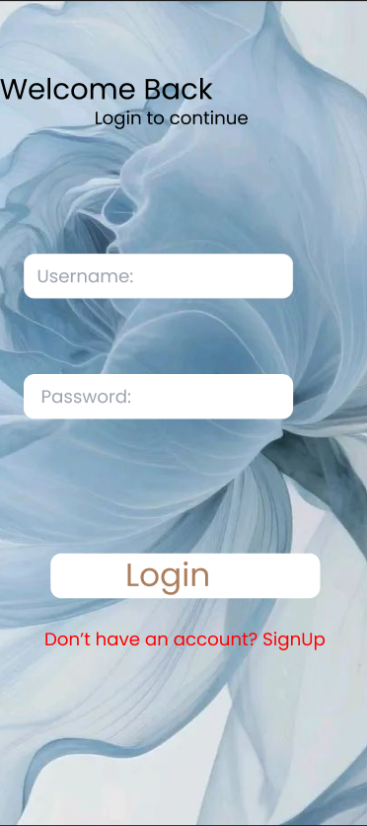
- BloomBudget Login screen

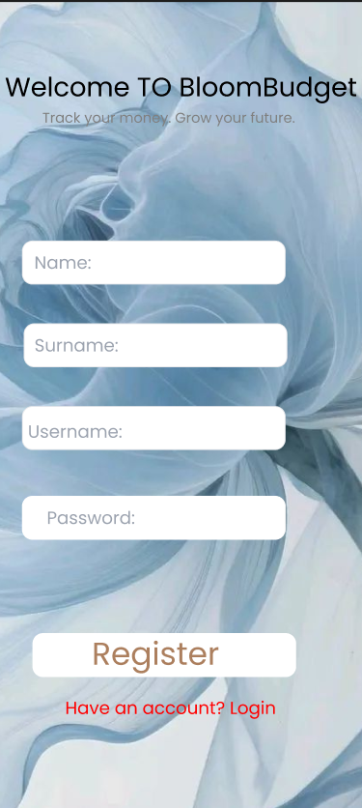
- BloomBudget Registration screen

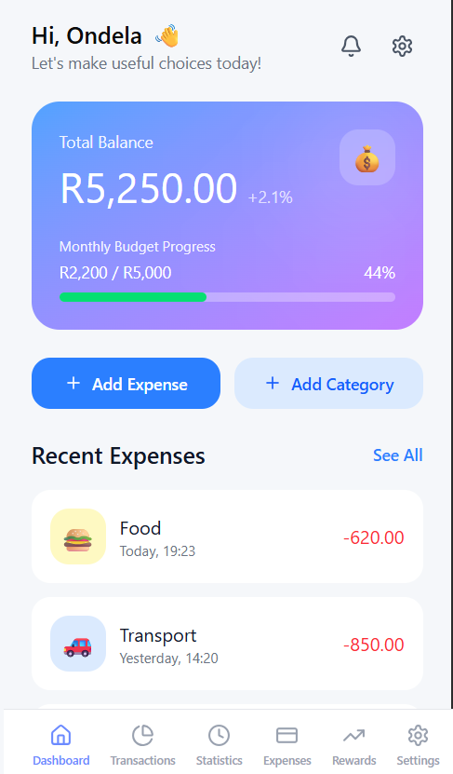
- BloomBudget Dashboard screen

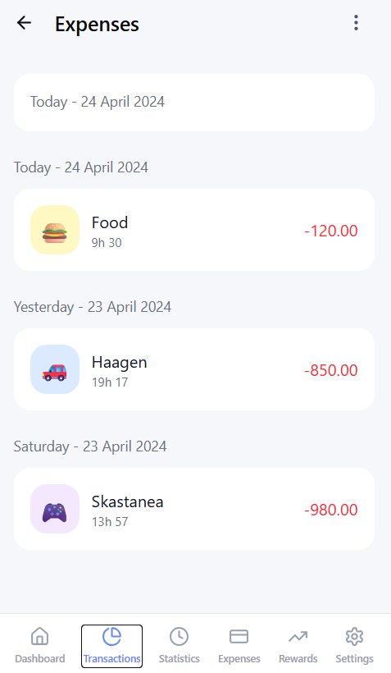
- BloomBudget Transactions screen

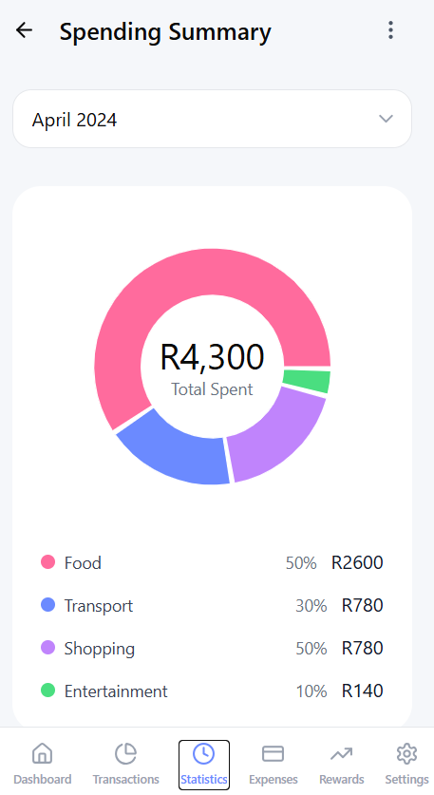
- BloomBudget Statistics screen

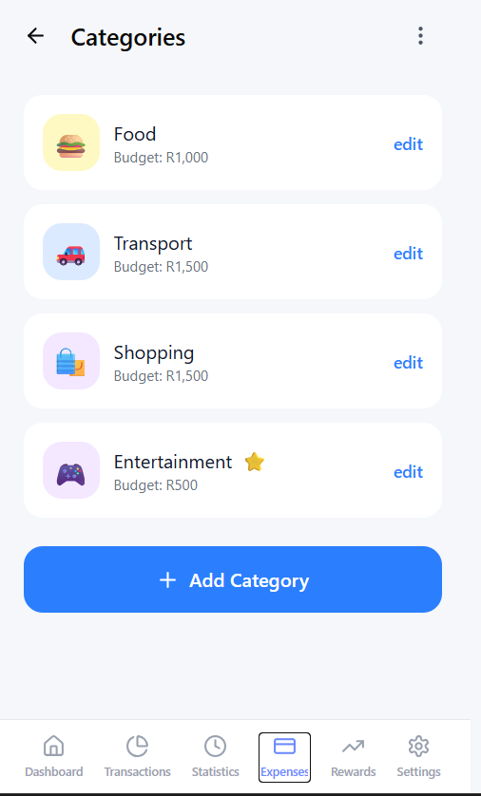
- BloomBudget Expense screen

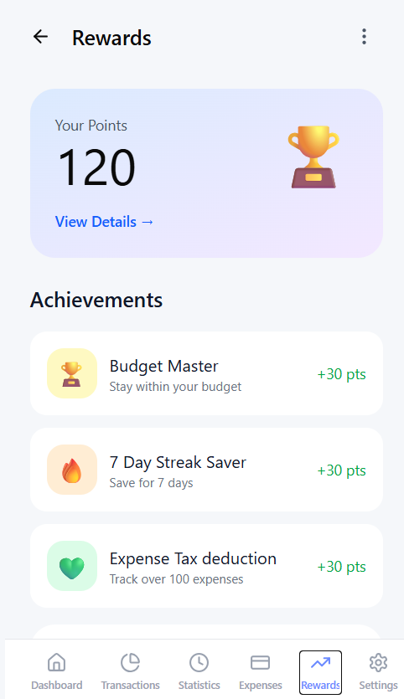
- BloomBudget Rewards screen

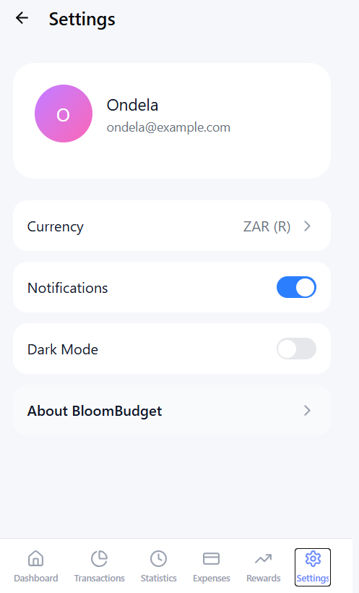
- BloomBudget Settings screen

Entity Relationship Diagram (ERD):
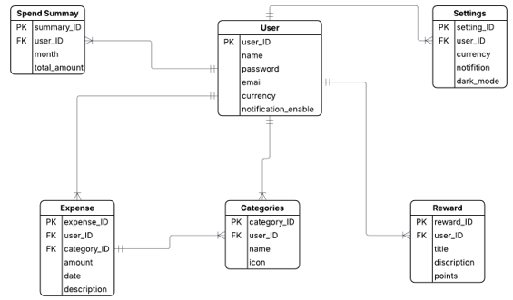

The Diagram below is a visual representation of how the BloomBudget application entities relate to each other.

Project plan:

This is the project plan which defines the specific tasks that will be performed during this project, and the allocations of those responsible for the designated tasks. The start date for the project is on the 17th of February 2026, which means that is when the first task of the project can be done. The project plan consists of the tasks from the planning phase, the design phase, the build phase, and the deployment phase. The planning phase includes the research and planning. The design phase is where the features and the user interface design of BloomBudget are defined and explained. The build phase is where the features of BloomBudget are implemented, and gamification is added. The deployment phase is where the prototype version of the app is released before the official release of the budgeting application. That will be the end date of the project, which is on the 26th of June 2026. It is essential to create a project plan because it enables an individual to picture the whole project from start to finish so that a strategy that is easy to understand and follow can be developed, (Debara, 2023).

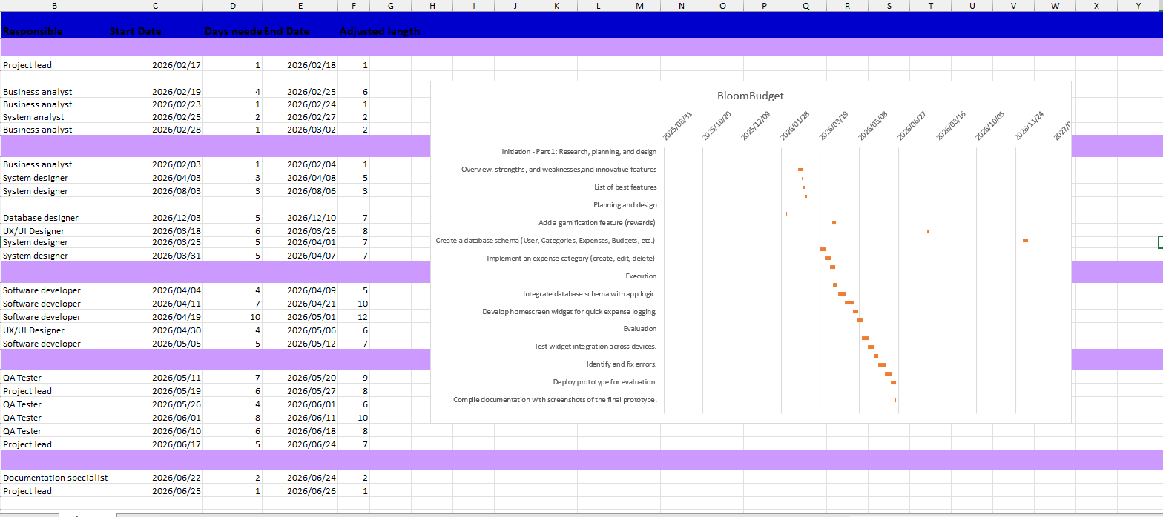

Conclusion
BloomBudget is designed to empower users with its simple and visually engaging tools for managing finances. This app combines standard budgeting features such as users recording expenses, monthly expenditure reports, and a wallet system which enables users to create more than one budget, with innovative designs such as the home screen widget panel, shared wallets for collaboration, notification alerts, and bank connectivity. This document also contains a project plan which details the designated tasks that will be completed during the project and states who will do which task and when they should be started and completed. The ERD describes how the database will interact with the application. Our document provides necessary information about BloomBudget to enlighten users and developers on how the application will look and function.

Improvements on section 2

Introduction
This report evaluates the development of BloomBudget, a personal budget application designed with a clean and intuitive interface to help users navigate their financial behaviours smoothly. BloomBudget aims to promote responsible money management by allowing users to track their income, expenses, and savings in a structured and visually engaging platform, while also supporting goal-oriented budgeting and collaborative financial planning with friends and family.
As established in the previous report, Spendee, Vault22, and Wallet served as key research references, providing insight into the general features of budgeting applications and how they are implemented in real-time. Building on those findings, this report reflects how each application informed specific design decisions for BloomBudget. From Spendee (Bitget, 2026), the use of colourful icons and simple graphs was adopted to make the budgeting experience visually engaging and accessible. From Vault22 (Digital Humanity, 2025), the significance of South African bank connectivity was recognised as an important feature. From Wallet (BudgetBakers,2024), the cluttered dashboard design served as a cautionary example, influencing BloomBudget's commitment to a clean and focused user interface. Together, these insights have helped shape an application that is both informed by existing tools and distinctly its own.

Overview of the App
Name of the app: BloomBudget
Slogan: Track your money. Grow your future.
Initial Icon Design:



Innovative features:
- Home screen widget: BloomBudget will offer a feature where users can add or log expenses into their budget via the home screen. This aims to provide a shortcut for the users rather than going into the application.
- Notification reminders: Users are issued reminders
- Questionnaire: Provide a few questions asking the user about how well-versed they are in budgeting to offer additional assistance if they are not well educated.
- Shared wallets: Group budgeting feature for families, friends, or teams to manage collective expenditure.
- Bank connectivity: The ability to connect to local banks

Requirements list
User registration and login
- The user must be able to register and login to the app using a username and password. When they register, they must fill in their first name, last name, their username, and then create a password. The user is only required to enter their username and password when logging in.
Registration:
- User provides: First name (2-35 chars), Last name (2-50 chars), Username (4-20 characters, a number, unique), Password (minimum of 8 chars, at least 1 number and 1 uppercase letter).
- User can view their password just in case of a missing variable by pressing the show and hide icon.
- System validates all fields, checks username uniqueness, and uses a hashed password for more security.
On success: "Registration successful - please log in".
On failure: Specific error message (e.g., "Username already exists").

Login:
- User enters username and password.
- System validates against stored hash.
- Should the user fail after 3 failed attempts, a 30-second lockout can occur.
- On success: Navigate to the dashboard screen until the registered user logs out.
- On failure: The system displays an "Invalid username or password" message.

Expense Categories
- The user must be able to create, edit, and delete categories for expenses. These categories must consist of Entertainment, Food & Drinks, Shopping, Bills & Fees, Health, Transport, Travel, Groceries, Car, and Personal. This requirement is to ensure that the user can study their spending habits and which expenses use a lot of money.

Expense Entry
- The user must be able to add an expense entry, specifying at least the amount, date, description, and category. This requirement is to provide specific details about the expense entry, which will assist the user for future planning.
- The user must be able to optionally attach a photo. When the user adds the expense entry, the photo must be visible on the dashboard. This aims to help the user remember visually what the entry was logged for.
Report
- The user must be able to view a list of all expenses during a user-selectable period. This requirement is to enable the user to see the transactions that took place during the selected time period. The user can view the transaction weekly, bi-weekly, monthly, or annually.
Budget goal setting
- The user must be able to set a monthly total budget goal and specific limits for individual categories. This requirement is to ensure that the user does not go overboard on certain expenses unnecessarily. For example, the user will set a limit of R450 on the Entertainment category to ensure that they do not exceed this limit for that month.
Database
- All this data must be saved to the local database. Data integrity will be maintained through encryption protocols. This is a requirement so that data can be easily managed and retrieved efficiently.
Graph and visualization
- The user must be able to view a graph showing daily spending over a user-selectable period. This assists the user by tracking their spending habits visually. With the use of graphs, it is easier to identify certain trends in the spending and overall understanding the presented data.
Homescreen widget
- The user must be able to add the app’s widget into their home screen. This should allow them to add or remove expenses on their homescreen.
Notifications
- The user must be able to receive notifications about their progress or reminders to log and review budgets.
Shared wallets
- The user must be able to share their wallet or budget with their friends or family. They must be able to make changes to entries or add their own entries on the same account.
Bank integration
- The user must be able to connect their bank to the application.

User Interaction Design

Screenshots

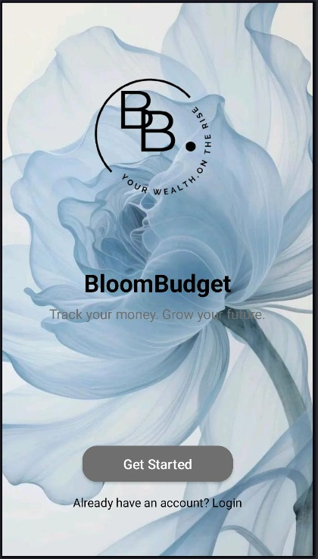
- BloomBudget main screen.
Displays the app logo and slogan.
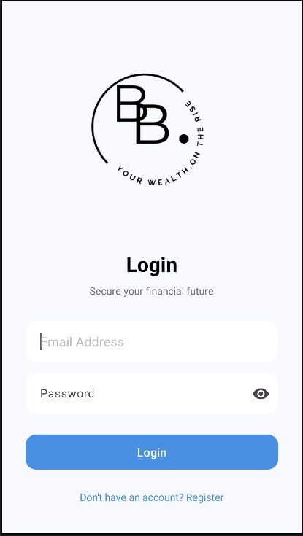
- BloomBudget Login screen
This screen authenticates existing users by validating their username and password against stored credentials. Upon successful login, the user is navigated to the Dashboard. Failed attempts display an error message and allow retry.

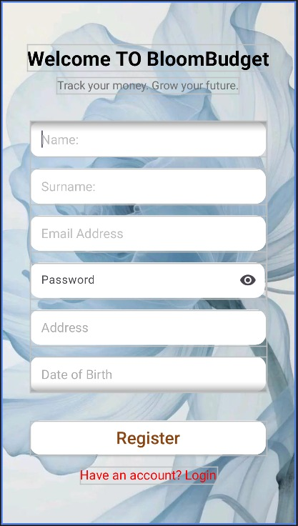
- BloomBudget Registration screen
Allows new users to create an account by providing their first name, last name, username, and password, then register. The information will be stored or recorded to allow them to log in on the login screen.
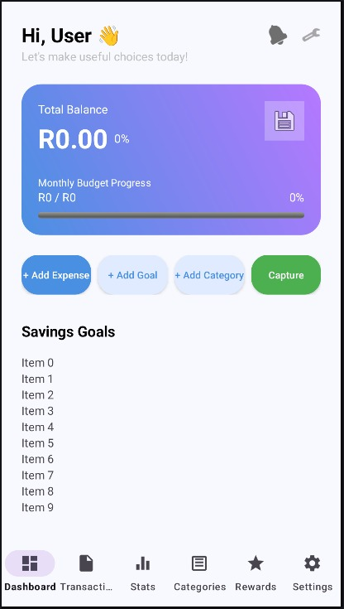
- BloomBudget Dashboard screen
The Dashboard displays the user's current month budget progress, which includes the total spent vs total budget, category spending status, and highlights any possible overspending categories. It includes the following buttons: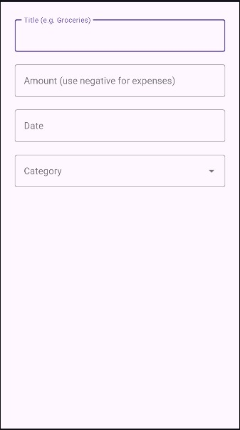
- Add expense – Allows users to add their daily or weekly expenses. It is beneficial to the user as they will keep track of their finances and also earn points or daily streaks.

- Add category – It allows the user to add their expenses in categories.
- Capture – The system enables your phone camera to open, where you can take a picture of your monthly statements or receipts, which can help you budget for future expenses.
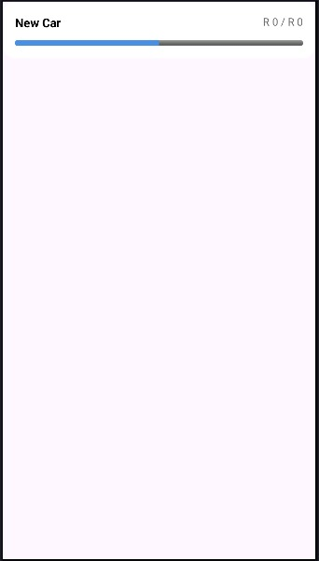
- Add Goal – Set target and track progress: This feature provides you with a way to help you set a goal or target, create a budget, and add money for a specific duration of time, while tracking how far or close you are using a progress bar in real-time.

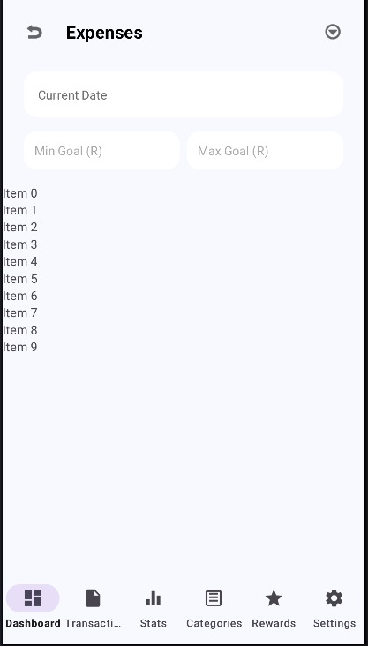
- BloomBudget Transactions screen
Enables users to record a new expense by entering an amount, date, description, category, and optionally attaching a receipt photo.
Displays all expenses in chronological order grouped by date, with category icons, descriptions, amounts, receipt camera icons, and date filters for weekly, monthly, or custom ranges.
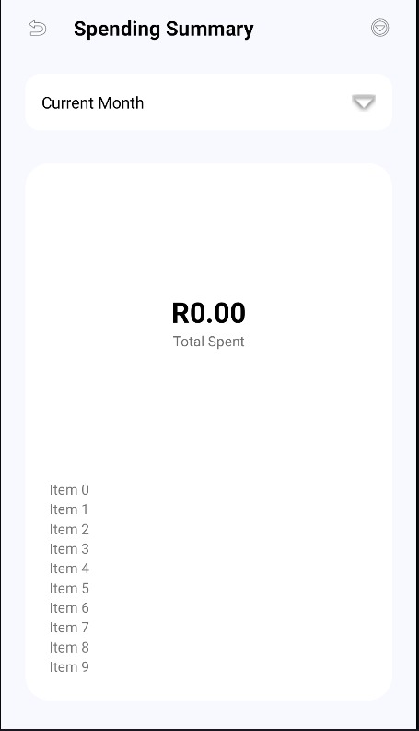
- BloomBudget Statistics screen
Displays pie charts and bar graphs showing total spending per category for any user-selected date period.
Displays pie charts and bar graphs displaying total amount spent per category for any user-selected date period, with functionality to view individual expenses.
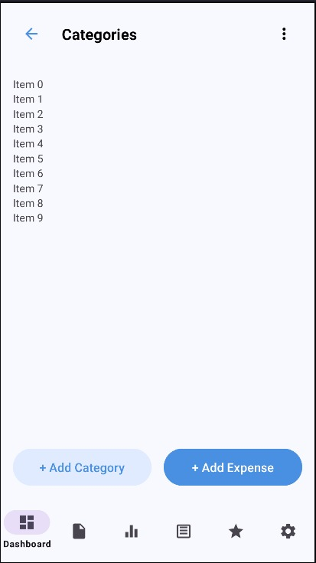
- BloomBudget Expense screen
Shows all expenses in a chronological list with category icons, amounts, and dates, with filters for weekly, monthly, or custom date ranges.
Enables users to add a new expense by entering amount, selecting date from a date picker, adding description, choosing a category from a dropdown, and optionally attaching a receipt photo from camera or gallery.
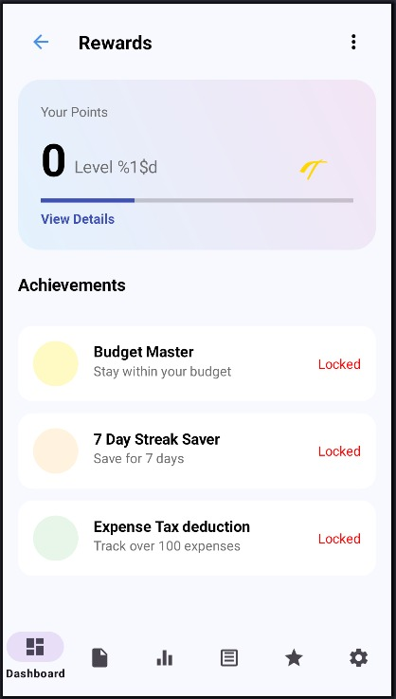
- BloomBudget Rewards screen
Displays all earned and unearned badges, shows progress towards next badges (e.g., "5/7 days for 7-Day Streak"), and shows an animation when a new badge is unlocked. At the bottom, the user can scroll down for more details on how the user can unlock a new level or earn new points.
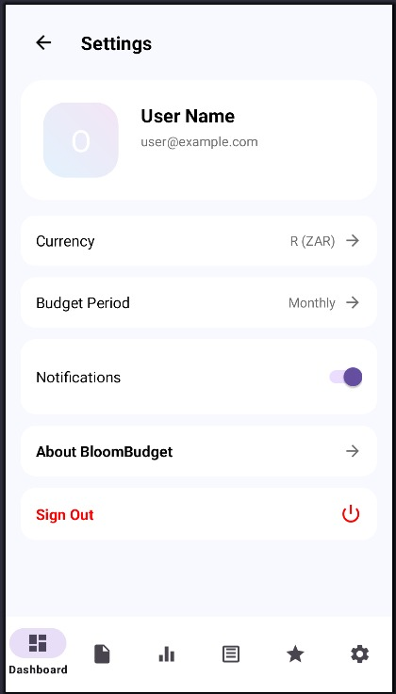
BloomBudget Settings screen
Allows users to log out, export all or delete all user data, manage categories (add/edit/delete), and set notification preferences; the user can switch to dark mode.

UML Use-case diagram
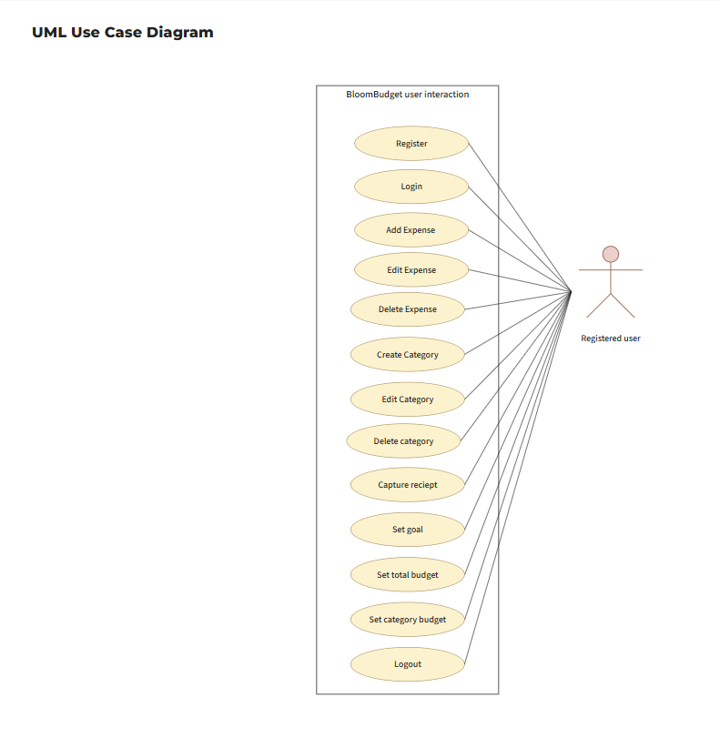

Project plan
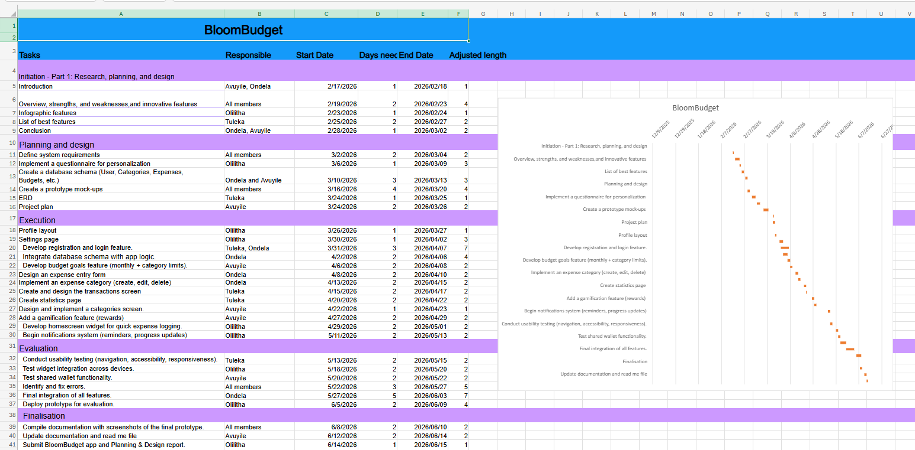

References
Bitget, 2026. Spendee Budgeting App Review: Features, Pricing & Comparison Guide 2024. [online]. Available at: < bitget.com/de/academy/12560603867395>
[Accessed 23 May 2026].
BudgetBakers, 2024. Wallet. [App]. Available at: <https://budgetbakers.com/en/ >
[Accessed 26 May 2026].
Digital Humanity, 2025. Best 4 Budgeting Apps in South Africa [How to Choose or When to Build Your Own App Guide]. [online] Available at: <https://digitalhumanity.co.za/insights/budgeting-apps-south-africa/ >
[Accessed 20 May 2026].
Debara, D., 2023. How to write an effective project plan in 6 simple steps. [online] Available at:
<https://www.atlassian.com/blog/project-management/write-an-effective-project-plan>
[Accessed 1 April 2026.]
Fernandez, A., 2025. Transforming Data into Knowledge: the Main Advantages of Data Visualization. [online] Available at:
<https://becolve.com/en/blog/transforming-data-into-knowledge-the-main-advantages-of-data-visualization/>
[Accessed 28 March 2026.]

